WPA-PSK and WPA2-PSK Cracking Module

Introduction
Decision Group introduces WPA-PSK (TKIP) and WPA2-PSK (AES) cracking module which is available. This module allows recovery of WAP-PSK (TKIP) and WPA2-PSK (AES) password/key, especially some weak passwords consisting of words and phrases in spoken language. By utilizing Wireless-Detective system or other sniffer tools to capture the raw data packets containing the handshakes packets, user can use this WPA/WPA2-PSK cracking module to recover the password/key. The password/key obtained can then be used for the decryption, decoding and reconstruction of the WPA raw data collected.

Operation and Functionality
Password List or Dictionary Attack
This WPA/WPA2-PSK cracking module can utilize a single server/computer or utilize multiple/distributed servers/computers to perform password list or dictionary (which can be customized) attack to recover the password/key.

Distributed or Multiple System Architecture
A single server can process a single password or dictionary list. Depending on the number of password or dictionary lists available, user may use multiple servers, each processing a single password or dictionary list to run the recovery process. Decision can provide 10 password lists. By using multiple servers and multiple password or dictionary lists, speed of cracking and chance of obtaining the key can be increased.

Hardware or GPU Acceleration
Acceleration of password/key recovery process can be done by utilizing hardware acceleration or GPU acceleration method. This method makes use of graphic cards to accelerate the cracking process, which could be up to 30 times faster or more than normal quad-core Intel CPU per card. Some graphic cards from NVIDIA and ATI are supported.

 | Comparison WPA-PSK Password Cracking with different GPU
 |  | Password Per Second
 | Tesla S1070 |  |  |  |  |  |  | 52400
 | HD4870x2 |  |  |  |  |  | 31500
 | HD4870 |  |  |  |  | 15750
 | GTX 280 |  |  |  |  | 11800
 | Core 2 Quad Q6600 |  |  | 1100
 | Core 2 Duo E4500 |  |  | 480

Note: The speed of WPA-PSK cracking will increase with new and more powerful GPU Cards.

Compatibility
This WPA/WPA2-PSK cracking module is compatible and work with Wireless-Detective system. Wireless-Detective system can be used to capture the Wireless packets that contain the WPA/WPA2-PSK handshakes information. User can then manually export the raw data packets to the WPA/WPA2-PSK cracking module to manually crack the key. It also accepts raw data packets (with handshake packets) in PCAP or tcpdump format captured by using other sniffer tools.

Note:
Time required for cracking the WPA/WPA2-PSK always depends on the randomness (number only, alpha-numerical or full ASCII characters) and length of the password/key. It also depends on the quantity and quality of hardware or servers used for the password/key recovery process.

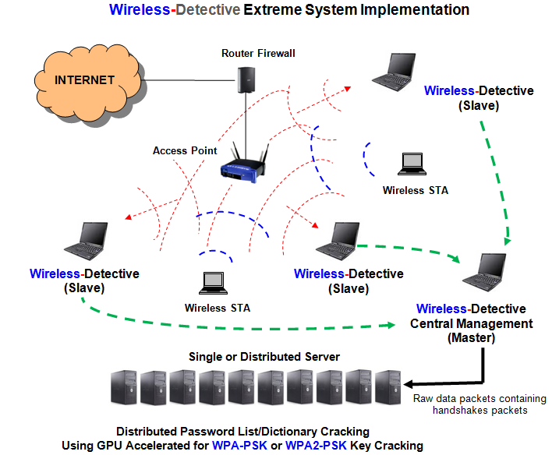

Standard WPA-PSK Cracking Module: (Desktop/Server System)
- Powerful CPU, Quad-Core CPU (32-bit server platform)
- Motherboard
- 2 PCI Slots – 1 PCI Slot for GPU Acceleration
- 1 x GPU Graphic Card
- Memory /RAM – 2-4 GB
- Hard Disk (SATA) – 320 GB
- A CD/DVD-ROM
- 1 x Ethernet Port
- Server with Windows OS (2000, XP, Vista, 7)

Others/Common Hardware Specifications: (Desktop/Server System for Reference)
- Single CPU, Dual-Core CPU or Quad-Core CPU (32-bit server platform)
- Motherboard (Server Motherboard preferred)
- Minimum 1 PCI Slot up to 4 Slots for GPU Graphic Card Acceleration
- GPU Graphic Cards
- Memory /RAM – minimum 1 GB up to 4 GB
- Hard Disk (IDE/SATA) – minimum 80 G.
- A CD/DVD-ROM
- 2 x Gigabit Ethernet Ports
- Server with Windows OS (2000, XP, Vista, 7)

Frequently Asked Question:
- What hardware are we using for GPU acceleration?
We use NVIDIA Tesla, GeForce 8-, 9-, 200-series or Quadro cards. Full list of supported NVIDIA devices can be found here. Besides, we can also use AMD/ATI Cards (AMD Firestream or Radeon HD3870 or HD4000-series card).

- What is the maximum supported number of GPU devices per system?
This is determined by the system motherboard. In theory, up to 8 devices can be installed (4 x PCI Express slots on motherboard, each with double GPU devices such as 9800GX2 or GTX295 or HD4870x2). By default, the WPA/WPA2-PSK cracking system delivered from us contains a single GPU device.

