Forensics Investigation Toolkit
User Guide

FIT Application Installation 2
[STEP1] - Download and install Java Runtime Environment 6.0 2
[STEP2] - Download and install Microsoft .NET Framework 2
[STEP3] - Install FIT 2
[STEP4] - Register and Active Product. 3
FIT Applications 4
Graphical User Interface 4
How to Analyze and Parse PCAP Raw Data Files? 5
How to Capture and Parse PCAP Raw Data Files? 8
Full Text Search and Bookmark 9
How to Decrypt QQ Password 11
How to Analyze Connections of Packets 13
Modification of System Parameters 15
Appendix A: Full-Text Search Function 15

FIT Application Installation

There are several steps to be taken for installing the FIT application as follow:

[STEP1] - Download and install Java Runtime Environment 6.0
JRE Download
JDK 6 Update 20 - Download JRE and Install.

[STEP2] - Download and install Microsoft .NET Framework
.NET Framework 2.0 Download
Download and install .NET framework.

[STEP3] - Install FIT
Please execute 'fit-setup2.X.X.X.exe' and follow the installation instructions.

[STEP4] - Register and Active Product.
- Please execute the “Generate Signature File” at FIT Application Group at Menu List. Before that, you must get the product Serial Number from Decision Group.
- Please send the Signature File to Decision Group for license registration. Decision Group will then reply with the License File for activating the FIT.
- Execute the “Register License File” and upload the license to activate the product.
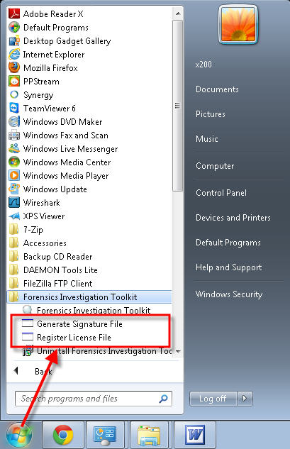

FIT Applications

Graphical User Interface

  - Menu Bar Features Items
  - Favorite Features Items
  - Object List
  - Record Table
  - Data Content List
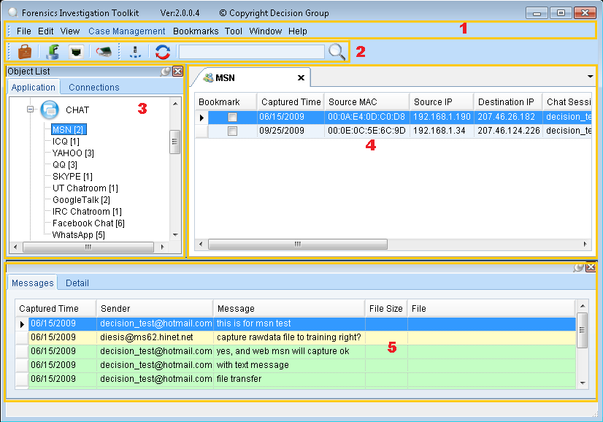

How to Analyze and Parse PCAP Raw Data Files?

- Create a New Case
You can create a new case from Menu Bar Feature Items or Favorite Features Items.
- Import Parse
Click on the Import file function and select a Case to add the PCAP raw data files for parsing.

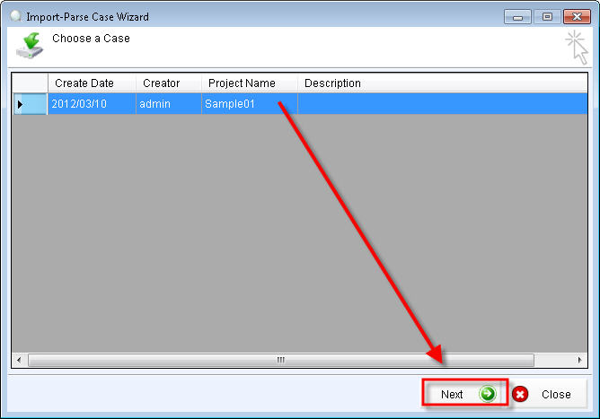
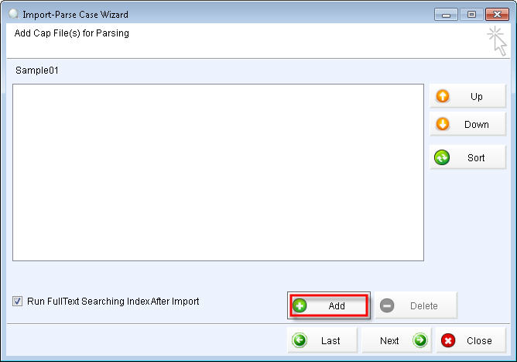
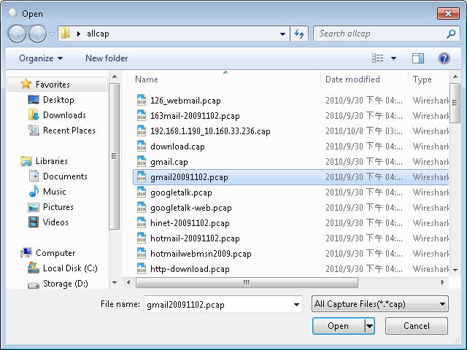
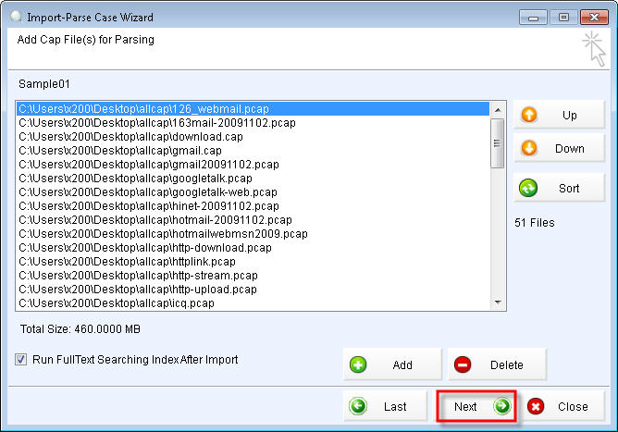
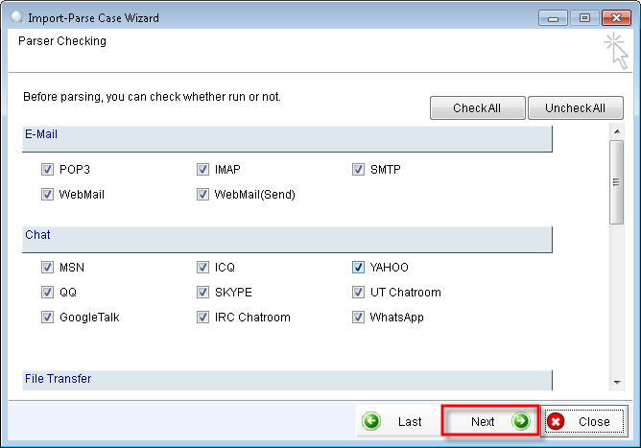
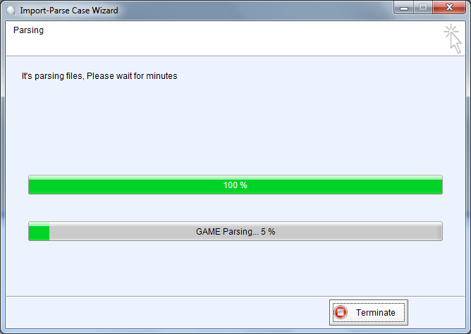

- View Results
Click on the Object Item to view the Record Table and Data Content List.

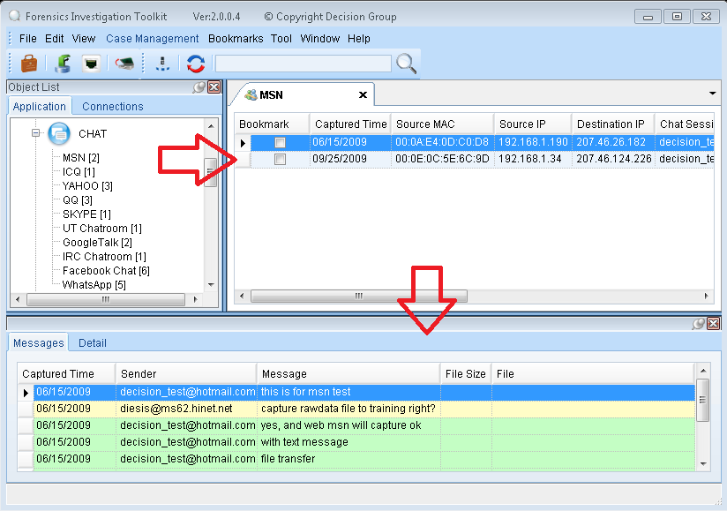

How to Capture and Parse PCAP Raw Data Files?
- Real time capture
Click on the Capture function and select a Case to add the PCAP raw data files for parsing.

- Choose Ethereal Device
Select a network adapter device with capture source to start sniffer packet.
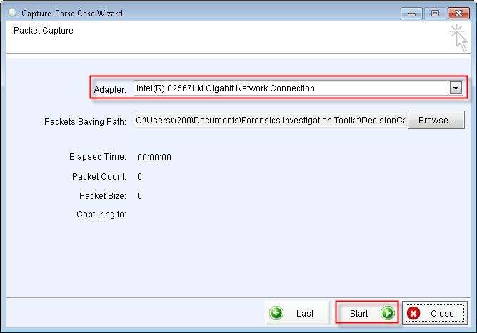

- Parsing Sniffer Packet
Press [ Stop ] to the work of parsing sniffer packet.
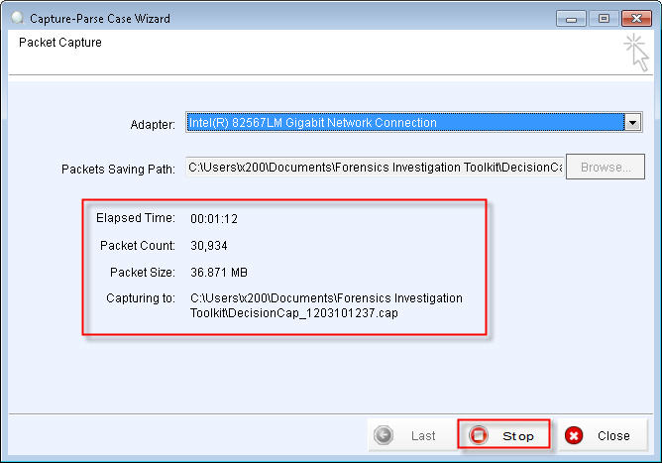

Full Text Search and Bookmark

Full Text Search
You can enter a key-word to search with the current opening case.
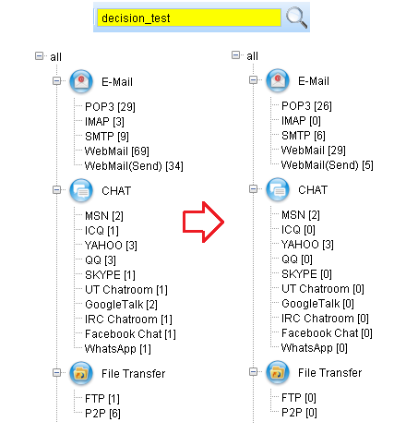
Object Result Bookmark
When the Full Text Search is completed, you can set filter items to bookmark the results for future reference.
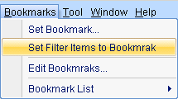
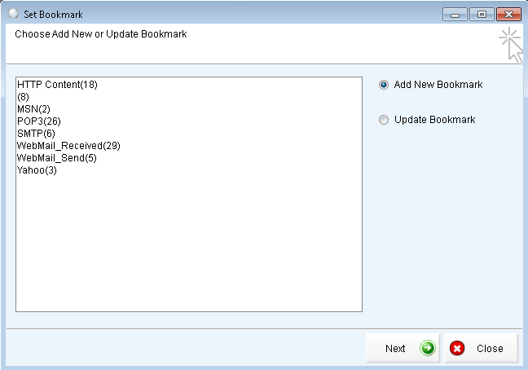
You can then review the previous Full Text Search result from the Bookmark List
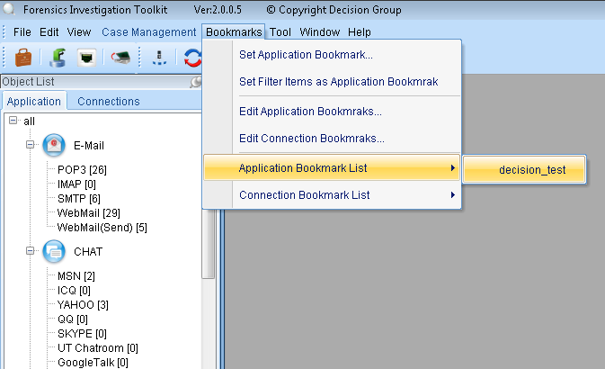

How to Decrypt QQ Password

As the QQ message is encrypted, we need to obtain the QQ password to decrypt the message content.

1. Input Password
If you already have this QQ account password, right-click on the record and enter the password to crack.

2. Execute the Cracking Tool
You can try to obtain the password by using the cracking tool. Right click on the record. Select execute cracking tool and choose a QQ message session to crack the password.
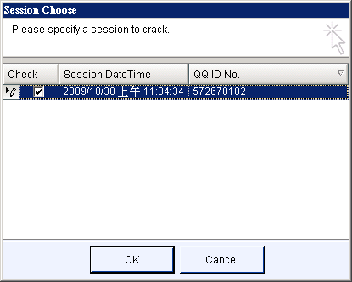

In QQ cracker option, yon must decide to use a dictionary attack or brute-force attack for cracking the password.
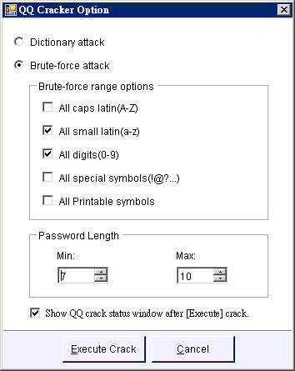
When you obtained the cracked password, you can click on  to decrypt QQ record with the password.
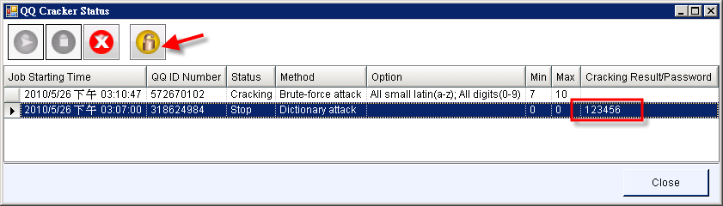

Encrypted Content
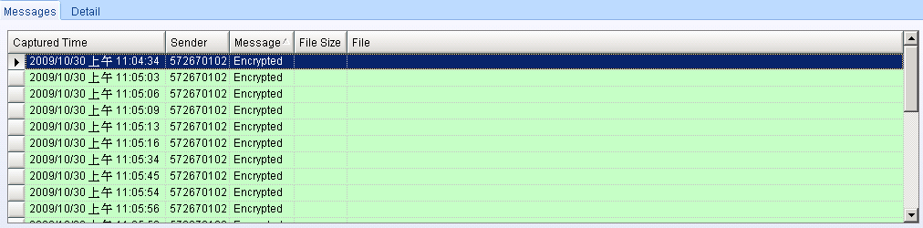
Decrypted Content
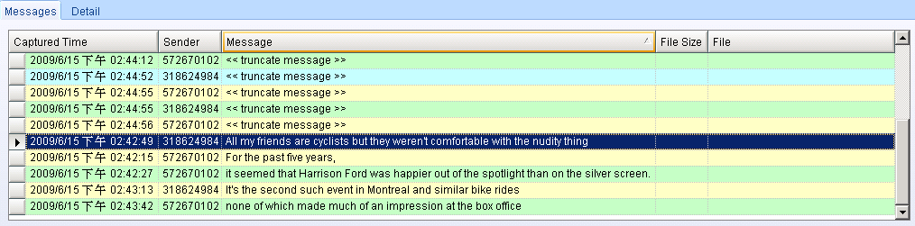

How to Analyze Connections of Packets

- View Connections
1. Open connection records in the Object List。
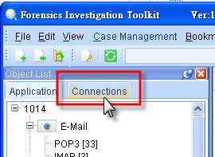

2. Choose the type of show the connection records。
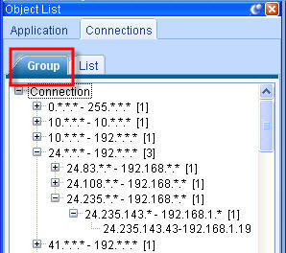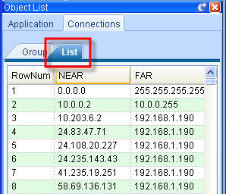

3. Click the connection record detail information will be observed。
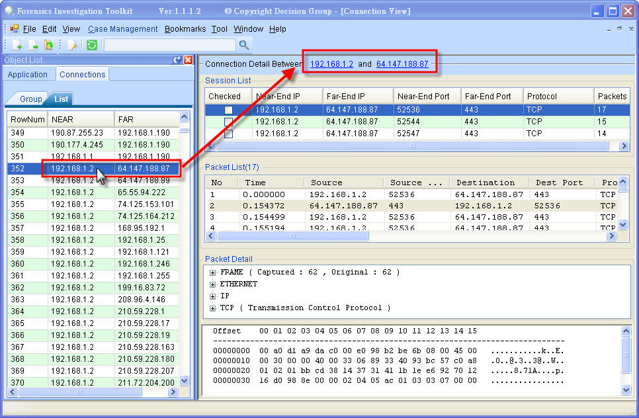
- Export Connection List
In the connection table, click right mouse button and choose to present the Connection List data export into PDF or CSV file for records storage。
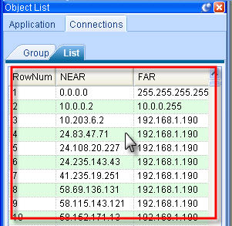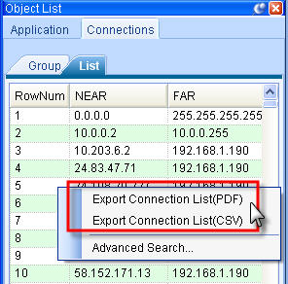

- Advanced Search
Also in the connection table, click right mouse button to open the Advanced Search, the conditions of the project through the Advanced Search you can search to filter connection record。

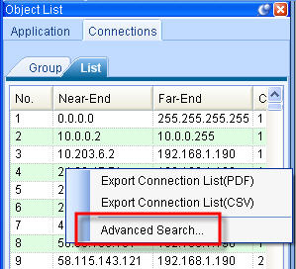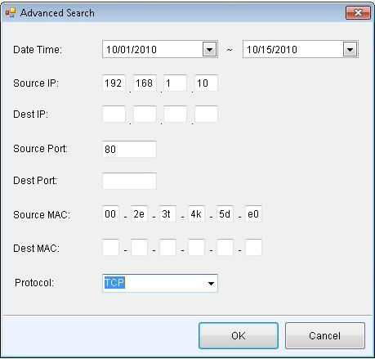

Modification of System Parameters
Modify GUI Wordings and Paramaters
If you want to modify the FIT GUI Wordings and Parameters, please access to the main Language folder in the Main Installation Directory. You can edit and modify them in the language file (for example: English.Ing).

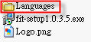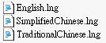

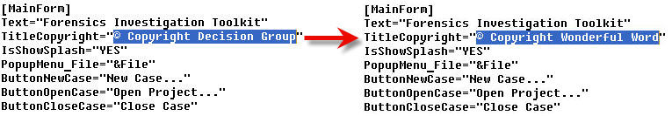

Appendix A: Full-Text Search Function
Full-Text Search function not only supports the keyword search but also supports data search by the specified fields of record. For example, if I want to query the sent mail records from ‘rickwang@decision.com.tw’ on 2008/09/16, I can give a query statement as below:
type:SMTP AND date:20080916 AND from:rickwang@decision.com.tw
The wild card searching is also supported in Full-Text Search Function. For example, if I want to get all the mail records sent from ’rickwang’, I can give a query statement as below:
type:SMTP AND from:rickwang*
The detail document of supported query syntax is listed in the extension chapter. What kinds of fields searching you can apply for each decoding record are defined as below:
[SMTP Mail Sending] (type:SMTP)
account - The target account of record
srcIp - Source IP address of record
mac - Source MAC address of record
date - Syntax format is ‘YYYYMMDD’. Ex. 20080916
time - Syntax format is ‘HHMMSS’. Ex. 231020
subject - Mail subject
from - Sender
to - Recipients
cc - Carbon copy
bcc - Blind carbon copy
ext - File name extension. Ex. doc, txt, exe, ...
[POP3 Mail Retrieving] (type:POP3)
account - The target account of record
srcIp - Source IP address of record
mac - Source MAC address of record
date - Syntax format is ‘YYYYMMDD’. Ex. 20080916
time - Syntax format is ‘HHMMSS’. Ex. 231020
subject - Mail subject
from - Sender
to - Recipients
cc - Carbon copy
bcc - Blind carbon copy
ext - File name extension. Ex. doc, txt, exe, ...
login - Mail server login account
[IMAP Mail Retrieving] (type:IMAP)
account - The target account of record
srcIp - Source IP address of record
mac - Source MAC address of record
date - Syntax format is ‘YYYYMMDD’. Ex. 20080916
time - Syntax format is ‘HHMMSS’. Ex. 231020
subject - Mail subject
from - Sender
to - Recipients
cc - Carbon copy
bcc - Blind carbon copy
ext - File name extension. Ex. doc, txt, exe, ...
login - Mail server login account
[Web Mail Sending] (type:WEBMAILS)
account- The target account of record
srcIp - Source IP address of record
mac - Source MAC address of record
date - Syntax format is ‘YYYYMMDD’. Ex. 20080916
time - Syntax format is ‘HHMMSS’. Ex. 231020
subject- Mail subject
from - Sender
to - Recipients
cc - Carbon copy
bcc - Blind carbon copy
service - Webmail service. Ex. YAHOO, GMAIL, HINET, ...
[Web Mail Retrieving] (type:WEBMAILR)
account- The target account of record
srcIp - Source IP address of record
mac - Source MAC address of record
date - Syntax format is ‘YYYYMMDD’. Ex. 20080916
time - Syntax format is ‘HHMMSS’. Ex. 231020
subject- Mail subject
from - Sender
to- Recipients
cc- Carbon copy
bcc - Blind carbon copy
service- Webmail service. Ex. YAHOO, GMAIL, HINET, ...
[MSN Messenger] (type:MSN)
account- The target account of record
srcIp - Source IP address of record
mac - Source MAC address of record
date- Syntax format is ‘YYYYMMDD’. Ex. 20080916
time - Syntax format is ‘HHMMSS’. Ex. 231020
msnOwner- Initiator of message communication
msnWhom- Participant of message communication
[ICQ] (type:ICQ)
account- The target account of record
srcIp - Source IP address of record
mac - Source MAC address of record
date - Syntax format is ‘YYYYMMDD’. Ex. 20080916
time - Syntax format is ‘HHMMSS’. Ex. 231020
icqOwner - Initiator of message communication
icqWhom - Participant of message communication
[Yahoo Messenger] (type:YAHOO)
account- The target account of record
srcIp - Source IP address of record
mac - Source MAC address of record
date - Syntax format is ‘YYYYMMDD’. Ex. 20080916
time - Syntax format is ‘HHMMSS’. Ex. 231020
yahooOwner- Initiator of message communication
yahooWhom- Participant of message communication
[QQ] (type:QQ)
account- The target account of record
srcIp - Source IP address of record
mac - Source MAC address of record
date - Syntax format is ‘YYYYMMDD’. Ex. 20080916
time - Syntax format is ‘HHMMSS’. Ex. 231020
qqOwner - Initiator of message communication
qqWhom - Participant of message communication
[SKYPE] (type:SKYPE)
account- The target account of record
srcIp - Source IP address of record
mac - Source MAC address of record
date - Syntax format is ‘YYYYMMDD’. Ex. 20080916
time - Syntax format is ‘HHMMSS’. Ex. 231020
[UT Webchat] (type:UT)
account- The target account of record
srcIp - Source IP address of record
mac - Source MAC address of record
date - Syntax format is ‘YYYYMMDD’. Ex. 20080916
time - Syntax format is ‘HHMMSS’. Ex. 231020
utOwner - Initiator of message communication
utWhom - Participant of message communication
[IRC Messenger] (type:IRC)
account- The target account of record
srcIp - Source IP address of record
mac - Source MAC address of record
date - Syntax format is ‘YYYYMMDD’. Ex. 20080916
time - Syntax format is ‘HHMMSS’. Ex. 231020
ircOwner - Initiator of message communication
ircWhom - Participant of message communication
[Google Talk Messenger] (type:GOOGLETALK)
account- The target account of record
srcIp - Source IP address of record
mac - Source MAC address of record
date - Syntax format is ‘YYYYMMDD’. Ex. 20080916
time - Syntax format is ‘HHMMSS’. Ex. 231020
googletalkOwner- Initiator of message communication
googletalkWhom- Participant of message communication
[Web Page Record] (type:HTTPPAGE)
account- The target account of record
srcIp - Source IP address of record
mac - Source MAC address of record
date - Syntax format is ‘YYYYMMDD’. Ex. 20080916
time - Syntax format is ‘HHMMSS’. Ex. 231020
host - Web Site hostname. Ex. www.google.com.tw
[HTTP File Download/Upload] (type:HTTPFILE)
account- The target account of record
srcIp - Source IP address of record
mac - Source MAC address of record
date - Syntax format is ‘YYYYMMDD’. Ex. 20080916
time - Syntax format is ‘HHMMSS’. Ex. 231020
host - Web Site hostname. Ex. www.google.com.tw
filename - Transferred file name. Ex. test.doc
ext- File name extension. Ex. doc, txt, exe, ...
[HTTP Video Clip] (type:HTTPVIDEO)
account- The target account of record
srcIp - Source IP address of record
mac - Source MAC address of record
date - Syntax format is ‘YYYYMMDD’. Ex. 20080916
time - Syntax format is ‘HHMMSS’. Ex. 231020
host - Web Site hostname. Ex. www.google.com.tw
filename - Transferred file name. Ex. test.doc
ext- File name extension. Ex. doc, txt, exe, ...
[FTP File Transfer] (type:FTP)
account- The target account of record
srcIp - Source IP address of record
mac - Source MAC address of record
date - Syntax format is ‘YYYYMMDD’. Ex. 20080916
time - Syntax format is ‘HHMMSS’. Ex. 23102
server- FTP Server IP Address
user - FTP login account
filename - Transferred file name. Ex. test.doc
ext- File name extension. Ex. doc, txt, exe, ...
[P2P File Transfer] (type:P2P)
account- The target account of record
srcIp - Source IP address of record
mac - Source MAC address of record
date - Syntax format is ‘YYYYMMDD’. Ex. 20080916
time - Syntax format is ‘HHMMSS’. Ex. 23102
tool - P2P toolkit. Ex. BitTorrent, Foxy, ...
ext- File name extension. Ex. doc, txt, exe, ...
[Telnet Communication] (type:TELNET)
account - The target account of record
srcIp - Source IP address of record
mac - Source MAC address of record
date - Syntax format is ‘YYYYMMDD’. Ex. 20080916
time - Syntax format is ‘HHMMSS’. Ex. 23102
server- Telnet Server IP Address
user - Telnet login account

