HTTPS/SSL Interception System
Standard Specifications

There are basically 3 different implementations/systems available for HTTPS/SSL interception:
- ED2S System – Utilizing Policy Based Routing of Existing network infrastructure (L3/4) to re-route targeted HTTPS traffic to ED2S System (Transparent Proxy Mode). Utilized for large network (Enterprise or ISP Lawful Interception).
- Standard HTTPS/SSL MITM Interception System – Select target by IP address within a LAN as target and utilizing ARP and DNS attack to redirect the particular target Internet traffic to the interception system.
- ED + HTTPS Proxy – ED is setup as a Web Proxy. Target users Internet traffic to be proxy to ED for Internet access. Utilized for SME and Enterprise networks.

 | HTTPS/SSL Interception System
Photo (for Illustration Only) | 
General Features and Functions
HTTPS/SSL Interception Function | Intercepting target user’s HTTPS/SSL Web Based Traffic (https://...)
HTTPS/SSL Traffic Interception and Implementation Method | - ED2S System – PBR (Transparent Proxy)  - Standard MITM System – ARP and DNS attack  - ED + HTTPS Proxy
SSL Version Supported | SSL v3 and below
Traffic Throughput | - ED2S System - Large Scale Network and ISP Interception up to about 100 Mbps per system.  - Standard HTTPS MITM System – 5 target users or more.  - ED + HTTPS Proxy - SME and Enterprise.
HTTPS/SSL - Decode and Reconstruction
Sample Retrievable Information | Date-Time, Account (Source IP Address, Destination IP Address, MAC Address), HTTP/HTTPS URL Link, Content, Reconstructed Web Page (eBay, Amazon etc.), Webmail Read and Sent (Gmail, Yahoo Mail etc.).
Username and Password Capturing | HTTP/HTTPS Target Websites Username and Password Login. Sample HTTPS Web Login like Yahoo Mail, Gmail, Amazon, eBay etc.
Other Features and Capabilities
Target Market | Lawful Enforcement Agencies (Military, Police, Intelligence, National Security, CID etc.)

Sample Screenshot of HTTPS/SSL MITM Interception (Obtainable Username/Password):
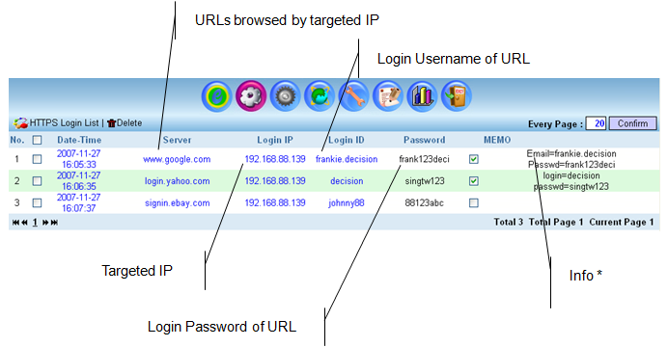

Note: Certificate Error Warning will appear at target user Web Browser. This problem can be resolved by having own trusted Certificate Authority (CA). For more information, please contact Decision Group.

