
Decision Computer Group
Cyber Forensics Specialist

Network Packet Forensics Analysis Training Course

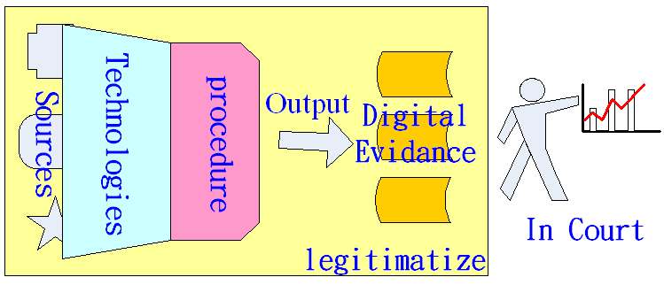

Step by Step and Easy to Learn

“Network Packet Protocols, Forensics Analysis & Content Reconstruction”
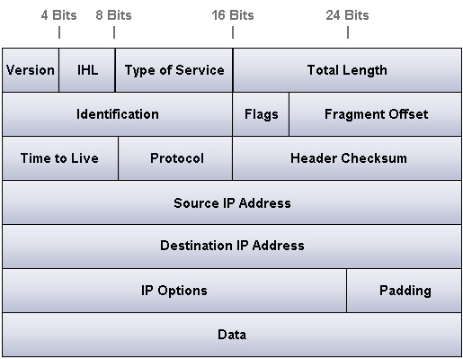
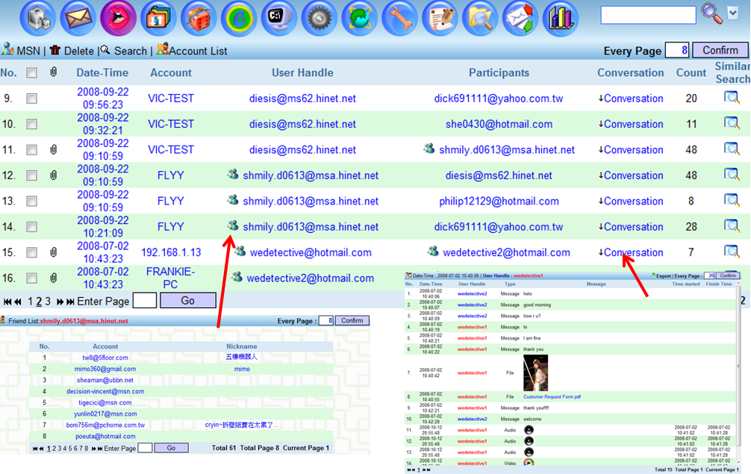

By Frankie Chan Kok Liang 2009
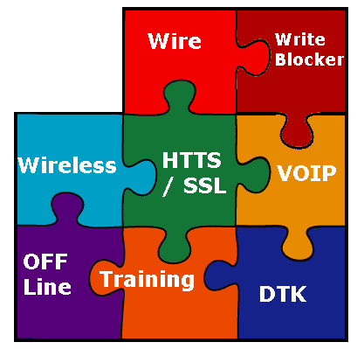

June 20, 2009 | DECISION COMPUTER GROUP (TAIWAN, SINGAPORE, GERMANY, USA)
Network Packet Forensics Analysis Training
Course Outline (Basic and Intermediate Level) – 3 Days

Module 1 - Basic Concepts
  - Introduction to Digital Forensics
1.1.1 Computer Forensics
1.1.2 Network Forensics
1.1.3 Mobile Forensics
1.2 Digital Forensics Processes
1.3 Digital Forensics Field
1.4 Introduction to Network Packets
1.5 Packet Sniffer and Analyzer Tool
1.6 Packet Reconstruction Tool

Module 2 - HTTP Network Packet Analysis
2.1 Introduction to HTTP Protocol
2.1.1 HTTP Client Connection
2.1.1.1 HTTP Web Access Procedures
2.1.1.2 HTTP Sample Packet Analysis
2.1.2 HTTP Host Connection
2.1.2.1 HTTP Host Service
2.1.2.2 HTTP Host Equipment Type
2.1.2.3 HTTP Host Operation and Packet Characteristics
2.1.2.4 HTTP Sample Packet Analysis
2.2 HTTP Upload
2.2.1 HTTP Upload Sample Packet Analysis
2.3 HTTP Download
2.3.1 HTTP Download Sample Packet Analysis

Module 3 - Email Packet Analysis
3.1 Common Email Architecture for Companies or Organizations
3.2 Email - SMTP
3.2.1 SMTP Email Sending Operation Analysis
3.2.5 SMTP Sample Packet Analysis
3.3 Email - POP3
3.3.1 POP3 Email Receiving Operation Analysis
3.3.2 POP3 Sample Packet Analysis
3.4 Email - IMAP
3.4.1 IMAP Email Receiving Operation Analysis
3.4.2 IMAP Sample Packet Analysis
3.5 Webmail
3.5.1 Introduction to Webmail
3.5.2 Webmail Sending Operation Analysis
3.5.3 Webmail Receiving (Read) Operation Analysis
3.5.4 Webmail Packet Analysis (Yahoo Mail, Windows Live Hotmail, Gmail)

Module 4 - Instant Messaging (IM) Packet Analysis
4.1 IM - MSN – Windows Live Messenger
4.1.1 MSN Host Service
4.1.2 Switchboard Server, SB
4.1.3 Notification Server, NS
4.1.4 Dispatch Server, DS
4.2 IM - Yahoo Messenger
4.2.1 IM – Yahoo Messenger Sample Packet Analysis
4.3 IM – Google Talk
4.3.1 Google Talk Sample Packet Analysis
4.4 IM - Skype
4.4.1 Skype P2P Service
4.4.2 Skype Sample Packet Analysis
4.5 IM – QQ
4.5.1 QQ Sample Packet Analysis
4.6 IM – IRC
4.6.1 IRC Sample Packet Analysis
4.7 IM – AOL
4.7.1 AOL Sample Packet Analysis
4.8 IM – IRC
4.8.1 IRC Sample Packet Analysis

DECISION COMPUTER GROUP
Email: decision@decision.com.tw and Website: www.edecision4u.com

4.9 IM - Others

Module 5 - FTP Packet Analysis
5.1 FTP Upload
5.1.1 FTP Upload Sample Packet Analysis
5.2 FTP Download
5.2.1 FTP Download Sample Packet Analysis
5.3 Web FTP

Module 6 - P2P Packet Analysis
6.1 Introduction to P2P Protocol
6.2 Various P2P Protocols
(BitTorrent, eMule/eDonkey, Fasttrack, Gnutella, Napster)
6.3 P2P Sample Packet Analysis (various protocols)

Module 7 - Telnet Packet Analysis
7.1 Introduction to Telnet
7.1 Telnet Sample Packet Analysis

Module 8 - Online Games Packet Analysis
8.1 Introduction to Online Games
8.2 Sample Online Games and Analysis

Module 9 - VOIP Packet Analysis
9.1 VOIP Protocols
9.2 RTP Protocols
9.3 VOIP CODECS
9.4 SIP Protocols
9.4.1 SIP Sample Packet Analysis
9.5 H.323 Protocols
9.5.1 H.323 Sample Packet Analysis

Module 10 - Video Streaming Packet Analysis
10.1 Types of Video Streaming
10.2 Video Streaming Sample Packet Analysis

Module 11 - HTTPS/SSL Packet Analysis
11.1 HTTPS Operation Principle
11.2 HTTPS Connectivity
11.3 HTTPS Sample Packet Analysis

Module 12 - Introduction to Wireless LAN Packets
12.1 Wireless LAN Technologies (Standards)
12.1 Open and Encrypted Wireless LAN Network
12.3 Wireless LAN Sample Packet Analysis

Module 13 - Case Studies for Network Crime Incidents
13.1 Case Studies 1
13.2 Case Studies 2
13.3 Case Studies 3
13.4 Case Studies 4
13.5 Case Studies 5
13.6 Case Studies 6

Module 14 - Packet Reassembly and Reconstruction
14.1 Introduction to E-Detective
14.2 Introduction to Wireless-Detective
14.3 Introduction to EDDC
14.4 Introduction to VOIP Interception
14.5 Introduction to HTTPS/SSL Interceptor

Module 15 - Certification Exam

